**Assignment 1: Setup & Fundamentals**

**Objective:**

To set up the CelerSMS AT Emulator and test basic AT commands to verify modem responsiveness and command execution.

**Tools Used:**

* **Cavli board - C10QM**
* **Operating System**: Windows 10
* **Teraterm serial terminal**

**Command 1: AT**

Description: To check if modem is alive

Response : SUCCESS: OK

FAIL: ERROR

Actual Response : OK

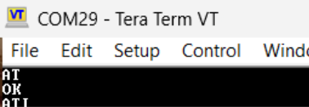

**Command 2: ATI**

Description: To get device Information

Response : SUCCESS: Manufacturer: Cavli Inc.

Model Name: CXXXX

Description: LTE Cat X Module 15

Modem Version: X.X.X IMEI: 35xxxxxxxxxxxxxx

Serial Number: QABCDE000000

Hardware Version: CXXXX_V0(0000)

Part Number:

SW Version: VX.X.X

Build Date:

FAIL: ERROR

Actual Response :

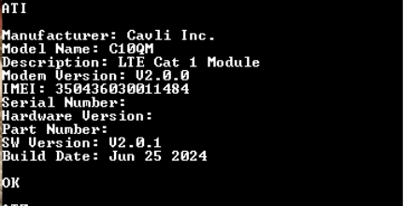

**Command 3: ATZ**

Description: This command restores the configuration profile.

Response : SUCCESS: OK

FAIL: ERROR

Actual Response : OK



**RESULT**

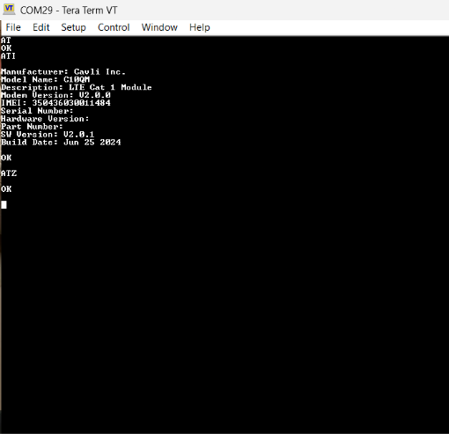

* Learned how to interact with the modem using AT commands.
* Understood the use of basic diagnostic commands.
* Verified command syntax and emulator responsiveness.